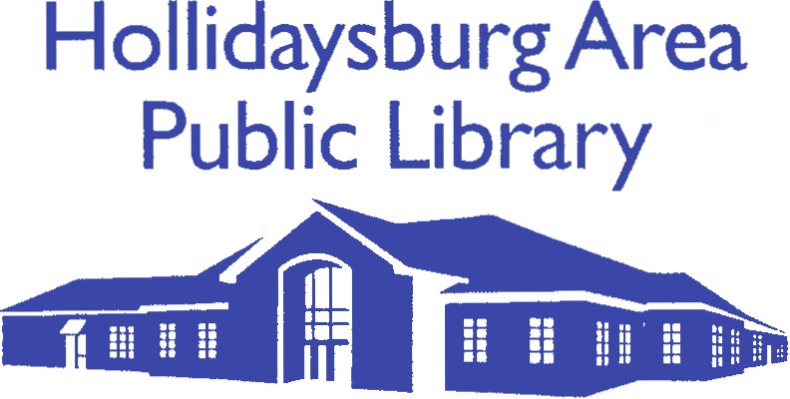
1 Furnace Road, Hollidaysburg, PA 16648

Position: Library Director

Reports to: Board of Directors

The Hollidaysburg Area Public Library, located in the Borough of Hollidaysburg in Central Pennsylvania, is seeking a dynamic, community-minded leader for the position of Library Director. The library serves a diverse population in the Hollidaysburg Area School District and nearby areas (service area: 24,043). It is a member of the Blair County Library System.

Position Summary: The library director plans, organizes, directs, evaluates, and reviews the library resources and programs to respond to the needs of the community. Duties include preparing and implementing the library’s short and long-term goals; developing and monitoring budget resources; community outreach; and supervising staff and services. This is carried out under the executive direction of the Library Board, in accordance with Board policies and objectives.

Job Requirements:

- Master’s degree in Library Science from ALA accredited program
- Public Library Certification as a professional librarian from the Pennsylvania Department of Education
- FBI and PA Criminal Background Checks and PA Child Abuse History Clearance
- Preferred two years of progressive library experience
- Demonstrated and successful leadership role in a community or non-profit organization
- Non-profit fundraising, development, and grant writing experience
- Interpersonal skills to collaborate with various internal and external groups
- Strong oral and written communication skills

Essential Functions:

- Manage the day-to-day operation of the library

- Lead, develop, administer, and coordinate the work of the library staff
- Perform managerial duties related to personnel, budget, payroll and benefits, collection development, and building maintenance
- Work with staff to present a broad range of activities for children, teens, and adults
- Prepare all required County and State reports
- Coordinate fundraising and Library development
- Support established fundraising events and help to envision new opportunities
- Pursue financial support on local, state, and national levels
- Identify and write grant applications

- Collaborate with the Board of Directors

- Identify, review, and fulfill the mission, vision, and values of the Library
- Evaluate Library performance and effectiveness
- Develop, review, and implement Library policies and procedures
- Review, update, and implement the strategic plan as needed
- Monitor, identify, and address relevant financial, operational, staffing, and facility matters

- Develop and maintain relationships with the community, including local governments, businesses, schools, community service organizations, Friends of Hollidaysburg Library, and the Blair County Library System

- Represent the Library at meetings and workshops
- Attend community events

Salary: $40,000 to $45,000 per year, commensurate with qualifications and experience.

Job Hours: Salaried full-time 35-hour work week, as well as occasional evening and/or weekend hours.

Benefits:

- 11 paid holidays per year
- One week of paid vacation for the first year, two weeks of paid vacation starting the second year, and three weeks of paid vacation after five years
- 12 personal days per year
- Health benefits
- Retirement

Applicants should email a cover letter, resume, and references (two personal and two professional) to Heather Lindskold, County Coordinator, at bcl@blaircountylibraries.org.

The position will remain open until filled.

